Example of SPP 11 Evaluation Log
(For Special Education Department Use)
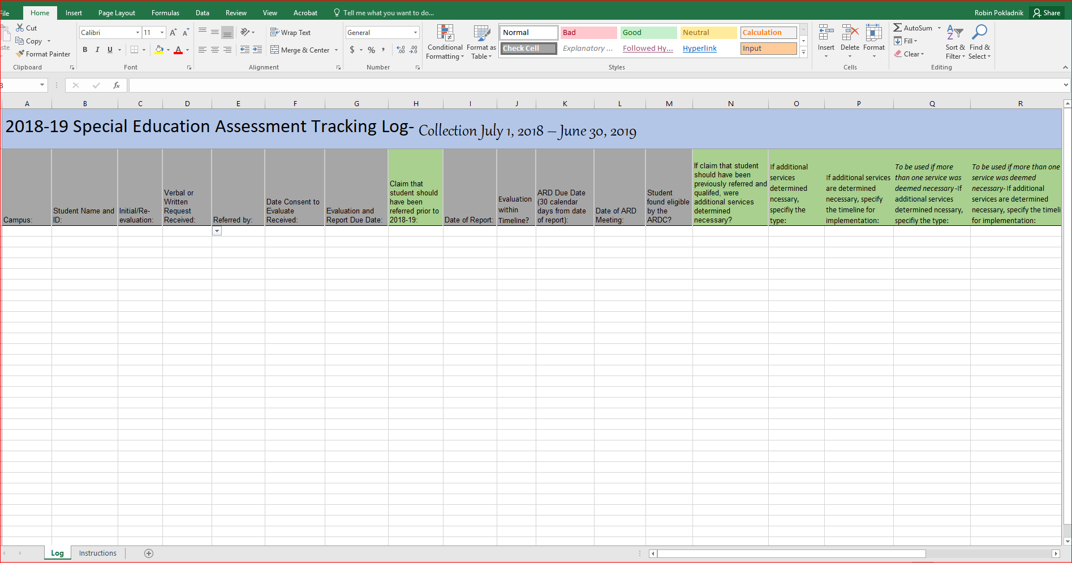

Instructions for Log Use
- Save the document (Excel file) to your computer
- Enter the campus and student information
- Select the type of evaluation
- Select the type of request received (verbal/written) and referral source, as applicable
- Enter the date signed consent received
- Enter the evaluation and report due date*
- Select if a claim was made that the student should have been referred prior to the 2018-2019 school year
- Enter the date of the completed report
- Select if the evaluation was completed within the established timeline
- Enter the date the Admission, Review and Dismissal (ARD) committee meeting is due
- Enter the date the ARD committee meeting occurred
- Select if the student was determined eligivle by the ARD committee
- Select and indicate additional services determined necessary, as applicable in columns N-V
*Note: Written report of an initial evaluation is due no later than the 45th school day following the date signed written consent is received. Additional exceptions may apply. Please see Full & Individual Evaluation (FIE) Interactive Timeline Tool for additional information.

